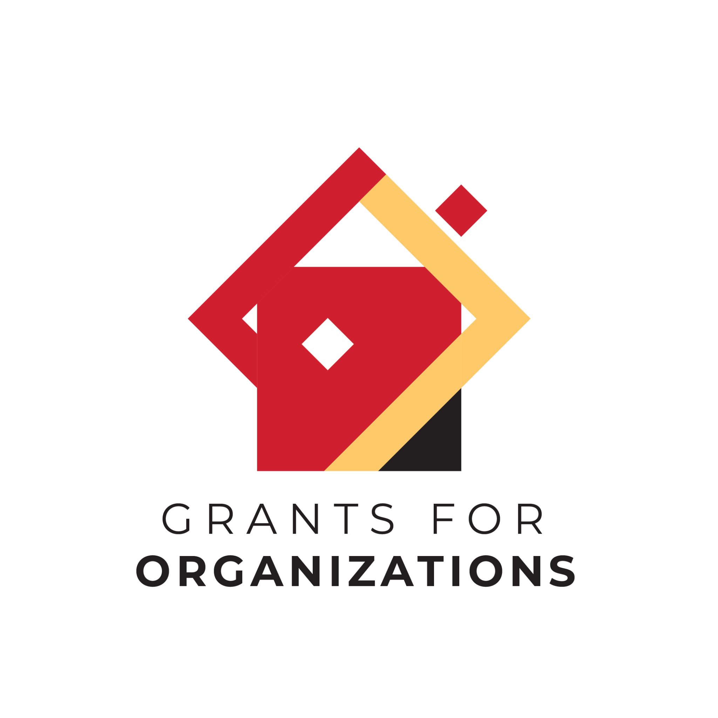
FY 2027 Grants for Organizations (GFO)
Application
Deadline - November 15, 2025
Narrative Questions, Financial Information + Attachments
NOTE: Are you applying on behalf of an Arts Organization or Arts Program?
- "Arts Organization" - your organization's mission/purpose is producing or presenting the arts through public programs or services.
- "Arts Program" - your organization's primary mission/purpose is other than producing or presenting the arts, but provides ongoing arts programming/activities through public programs.
- More info can be found in the FY27 GFO Grant Guidelines. If you are uncertain, contact your Program Director.

ORGANIZATIONAL & CONTACT INFORMATION

Applicants will be asked to update their Smart Simple organizational profiles with details about the organization/program. This is required information for the GFO application.

⚠️Click on the "Edit Org Profile" button below to insert and/or edit the information below

- Check/Edit the Organizational Contact information and required fields.
- Include the Effective Date of IRS 501c3 Exemption (This should be reflected on your IRS Letter of determination in the Attachment section.)
- Include your Mission, Vision, Goals and/or Values
- Federal Identification Number
- Applicant County
- Whether or not your organization is fiscally sponsored.
  - If yes, you’ll need to complete the required information.

⚠️To make edits to any of the information in your profile, click the Edit button.

ELIGIBILITY

* Has your organization operated for one full fiscal year? (Yes/No)

* Does your organization have ongoing programs to produce or present the arts to the public? (Yes/No)

* Please attach a 1-2 page summary of your annual arts programs with a short description of each activity. The list of events/arts activities may be categorized by program type (i.e. Mainstage Season, Classes, etc.) and number of corresponding occurrences that happen throughout a year.

- Please upload up to a 2 page summary of your annual arts programs with a short description of each activity. The List of Events/Arts Activities may be categorized by program type (i.e. Mainstage Season, Classes, etc.) and number of corresponding occurrences that happen throughout a year. This listing does not need to include specific shows/concerts/exhibitions/etc but rather the main programmatic categories (i.e. Mainstage Season, Classes, etc) presented each year.
- For Arts Programs, please include a list ALL programming that your organization offers (whether arts-based or not). Within this list, indicate what is an arts-based program with an asterisk (*).

* Do you anticipate any significant changes to the above programming in the next fiscal year? (Yes/No)
Significant changes would include situations in which programming is being added/eliminated or there would be significant increases/decreases in budget allocation for a particular program.

* Tell us about your organizational structure - click on all the groups that apply to your organization:
- A board of directors with officers or another type of governing body
- Paid staff members (full time, PT, and/or contractual)
- Volunteers (as staff, committees, etc.)

PROGRAM DETAILS

* Share up to 5 significant updates and/or highlights about the organization from the past fiscal year.
These should include significant changes to mission/vision/goals of the organization, staffing/leadership, operations, programming or other artistic activities, finances, etc. Within your response, include steps the organization has taken to address these changes, and any additional details to why these changes occurred.

Please note: You must include at least one update, but may include up to five total. If you are a new organization, consider including at least three updates.

Reminder: If you shared an update in the above section regarding your mission/vision/goals, please update your Organizational Profile with the updated mission/vision/goals

Optional - Are there any challenges that you’d like MSAC to be aware of, or ways we can support your organization in ways beyond your grant award?

* Share up to 5 goals/priorities of the organization over the next 5 years.
- Keep in mind indicators of success, ways to measure goals, and/or how you would implement
- Tell us about the timeframe for completion. These can be short term or long term goals.
- Goals/priorities may include activities associated with capacity building, finances, board/staff development, programmatic development, audiences/community engagement, new initiatives, etc.

Please note: You must include at least one organizational goal, but may include up to five total.

FINANCIAL INFORMATION

- Complete Financial Table: Enter the income and expenses for your arts organization’s or arts program’s most recently completed Fiscal Year (FY25 or CY24)
  - Resource: download a spreadsheet template from the website or request from the Program Director to use as a guide.
  - Information entered in the Financial Table should reflect the Financial Statement in the attachment section (see below).
  - *Arts Programs: This information should reflect your arts-based income and expenses, (rather than a full organizational statement).

ATTACHMENTS

- IRS Letter of Determination
- Completed and Signed Form w-9
- Financial Statement(s): Attach a financial statement (such as a P&L or audit, as described below) that reflects the numbers submitted in the Financial Table on the previous tab (Financial Information Tab).
  - For applicants with Allowable Income under $750,000:
    - A submission of the organization’s most recently completed fiscal or calendar year Financial Statement, signed by a professional accountant or the organization’s fiscal officer.
  - For applicants with Allowable Income over $750,000:
    - A submission of the organization’s most recently completed fiscal or calendar year Independent External Audit, prepared by a CPA firm.
- *Arts Programs Financial Statement (required for Arts Programs only in addition to full organization financials): Please attach a Financial Statement from the most recently completed fiscal or calendar year that is specifically for the Arts Program only (this should include the income/expenses directly connected to your arts programming only, not your full organizational financials)

